SUPPLEMENTARY FIGURES AND TABLES.
Supplementary Figures.
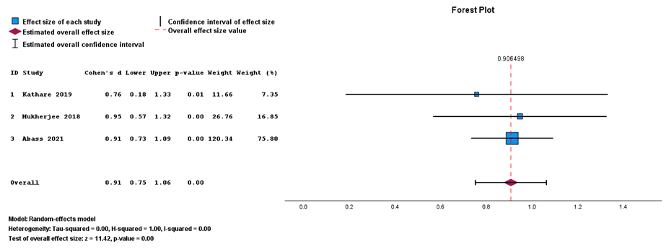
Figure. Forest plot for operative time based on data from observational studies. Three studies were included, and the estimated effect sizes and other effect sizes were reported. CI, confidence interval.

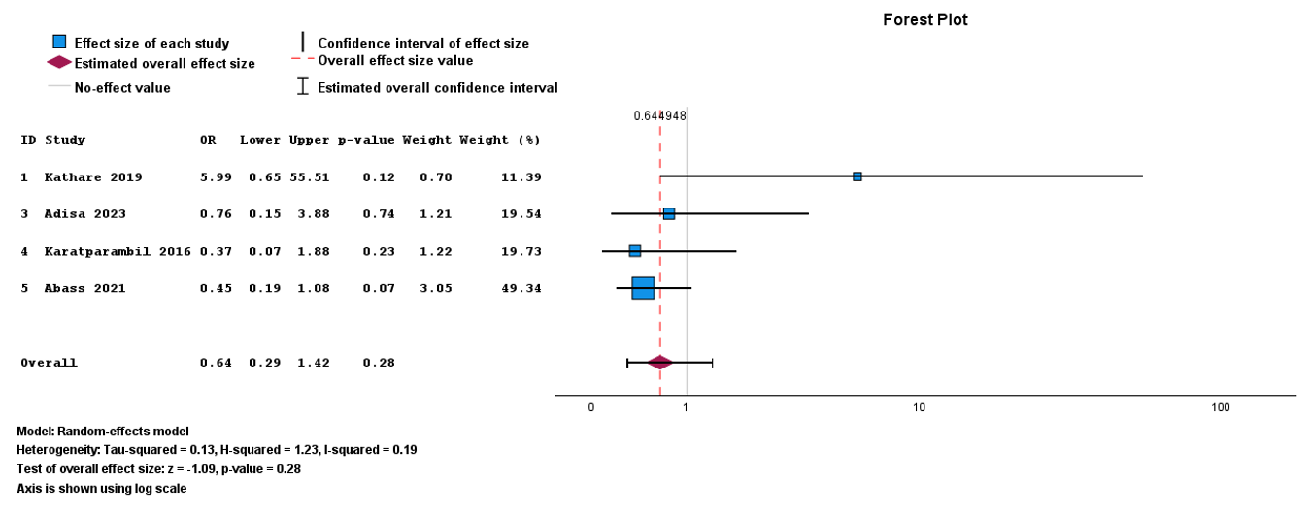
Figure. Forest plot for Surgical Site Infection (SSI) based on observational studies. Four observational studies were included, and the estimated effect sizes and other effect sizes were reported. OR, odds ratio; CI, confidence interval.

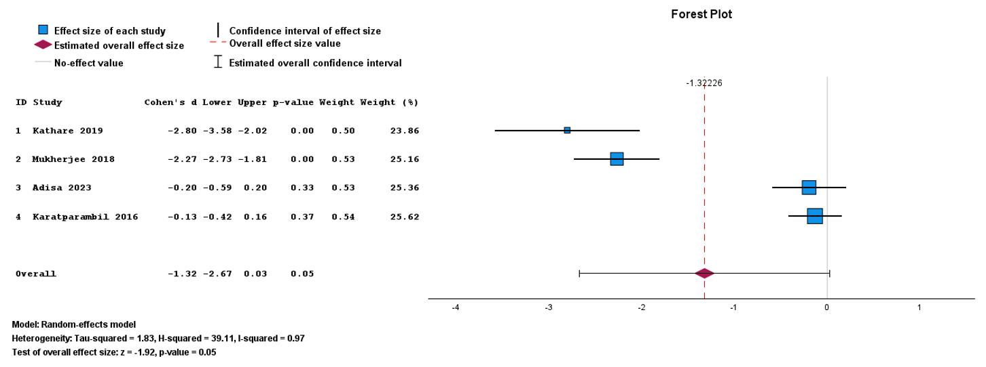
Figure . Forest plot for hospital stays based on data from observational studies. Four observational studies were included, and the estimated effect sizes and other effect sizes were reported. OR, odds ratio; CI, confidence interval.

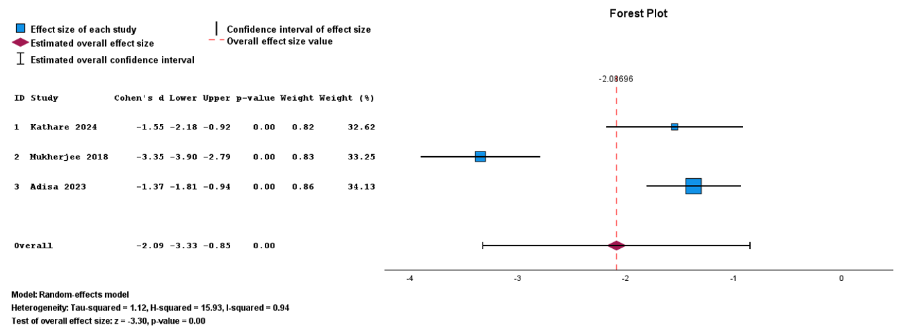
Figure. Forest plot for return to normal activity based on data from observational studies. Three observational studies were included, and the estimated effect sizes and other effect sizes were reported. Cohen’s d; CI, confidence interval.

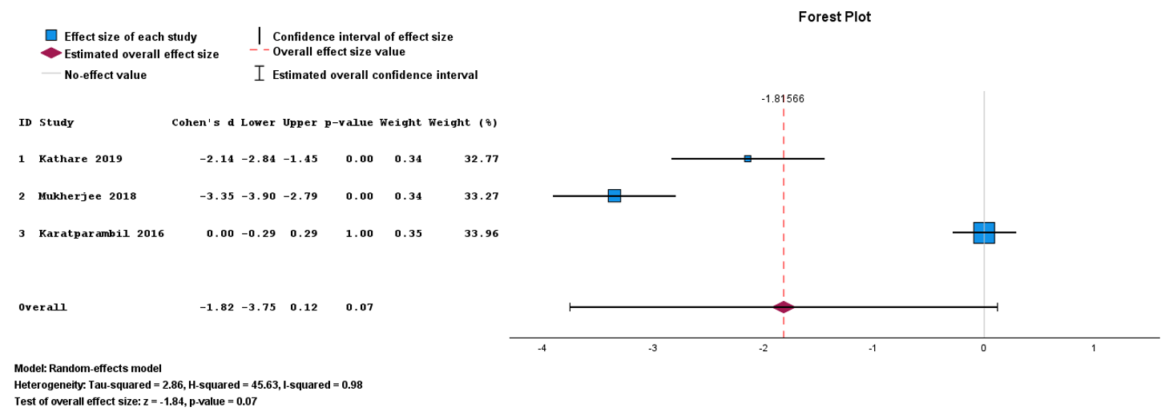
Figure. Forest plot for pain score based on data from observational studies. Three observational studies were included, and the estimated effect sizes and other effect sizes were reported. Cohen’s d; CI, confidence interval.

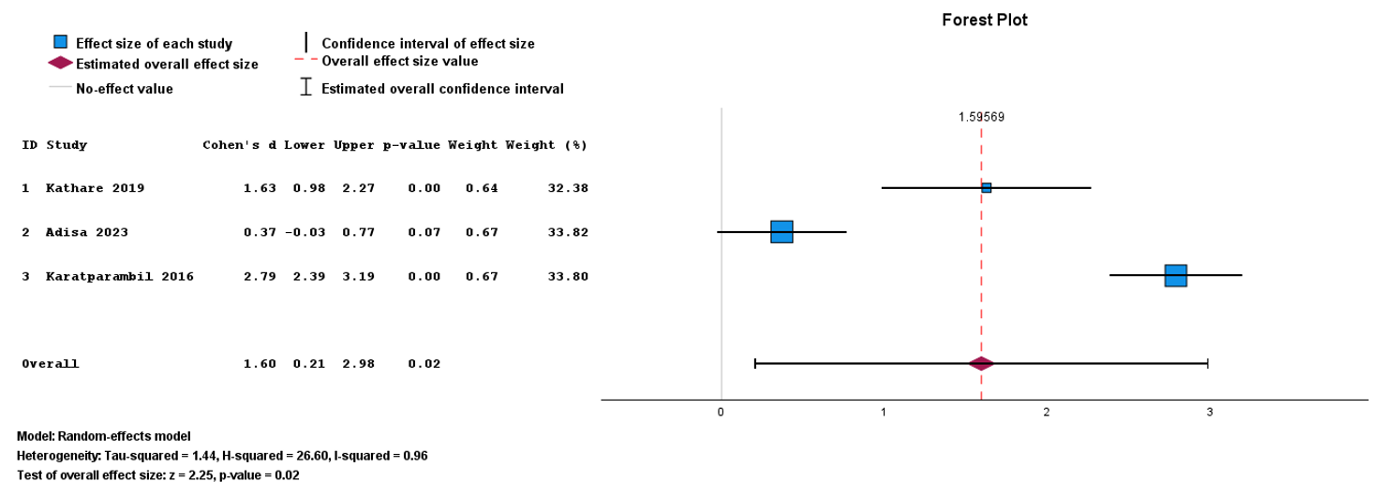
Figure. Forest plot for cost based on data from observational studies. Three observational studies were included, and the estimated effect sizes and other effect sizes were reported. Cohen’s d; CI, confidence interval.

Supplementary Tables

Table. Risk of Bias assessment for Randomized Controlled Trials (RoB 2 Tool)
 | D1 | D2 | D3 | D4 | D5 | Overall
Nazir 2019 |  | 
Moustafa 202
Barband 2020
Mba 2024
Mahmood 2016
Gul 2014
D1: bias due to randomization process; D2: bias due to deviation from intended interventions; D3: bias due to missing data; D4: bias in measurement of outcomes; D5: bias in selection of the reported results.

Table. Risk of bias using Newcastle-Ottawa Scale (NOS) assessment for observational studies (cohort and case-control studies)
 | Representativeness of exposed cohort | Selection of non-exposed cohort | Ascertainment of exposure | Demonstration that the Outcome of Interest was Not Present at the Start of the Study | Comparability of Cases and Controls on the Basis of the Design or Analysis | Assessment of Outcome | As Follow-Up Long Enough for Outcomes to Occur | Adequacy of Follow-Up of Cohorts | Overall
Mukherjee | 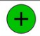
Adisa
Abass
Kathare |  |  |  |  |  |  |  | 
Nepal
Karatparambil
Shakya
Naidoo
Low risk, some concern, High risk

Table. Summary of Findings: Laparoscopic appendectomy (LA) versus Open Appendectomy (OA) in Low-Resource Settings (GRADE Evidence Profile)
Outcome | No. of participants (studies) | Relative effect (95% CI) | Absolute effect / Direction of effect | Certainty of evidence (GRADE) | Comments
Operative time | 1,200(6 studies studies) | Cohen’s d= -0.21 to 0.91 | Inconsistent; RCTs favor LA, observational favor OA | ⬜⬜⬛ ⬛ Low | Downgraded for inconsistency (I-squared = 98%). Direction differs by design, imprecision and indirectness.
Surgical site infection (SSI) | 1,700 (11 studies) | OR 0.5-0.64 (varies by design) | Fewer SSIs with LA, but not statistically significant in RCTs | ⬜⬜⬜⬛ Moderate | Low–moderate heterogeneity (I-squared = 19–59%). Imprecision ( Observational CI crosses line of no-effect).
Length of hospital stay | 1,600 (7 studies) | Cohen’s d= -0.79 to -1.32 | Shorter hospital stay but not statistically significant both in RCTs and observational. | ⬜⬜⬛⬛ Low | Downgraded for inconsistency (I-squared = 95%) and imprecision (RCT and observational CI cross line of null effect) and due to discharge criteria variability.
Return to normal activity | 850 (4 studies) | Cohen’s d= -2.09 to -1.37, | LA patients returned ~3 days earlier | ⬜⬜⬜⬛ Moderate | Downgraded for inconsistent (I-square=94% in observational studies), risk of bias (only 1 small RCT).
Postoperative pain score | 1,000 (5 studies) | Cohen’s d= -0.52 to -1.82 | Lower pain scores with LA | ⬜⬜⬜⬛ Moderate | Downgraded for imprecision (small number of studies, wide CI in observational) and substantial heterogeneity I-squared=98%
Cost | 700 (5 studies) | Cohen’s d= 1.99 (observational) | Higher direct hospital cost for LA | ⬜⬜⬛⬛ Low | Downgraded inconsistency (I-squared=90%) due to differing cost bases and currencies.
Certainty grading: ⬜⬜⬜ ⬜ = High ⬜⬜⬜⬛ = Moderate ⬜⬜⬛⬛ = Low ⬜⬛⬛⬛ = Very low

